**Hardware Design Project Part III**

**ENGR-304L-A**

**04/29/2025**

**Prof. Michmerhuizen**

**Team:** Piranavan Mahadevan, Sebastian Grabill, Samuel Knox, Onahi Ida-Michaels

**State Diagram for the Controller**

**Simulation**

**Clock Cycle Table**

**Quartus warnings**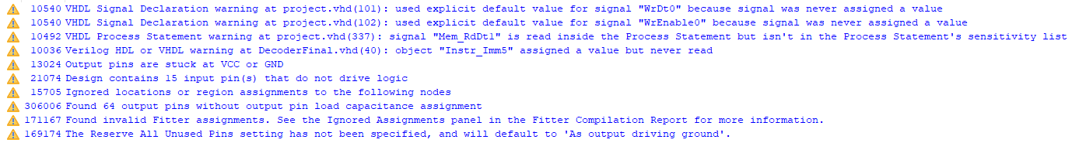

**Link to video demonstrating the system working:** [Engr304FinalVideoDemo](https://calvincollege-my.sharepoint.com/:f:/g/personal/oi23_calvin_edu/EiPUdX4Ok35Kh5zVVXcGHegBFEfJUSbiyLGTOGhW25jkbg?email=mark.michmerhuizen%40calvin.edu&e=SFL7Ge)

**\*All the VHDL Codes will be Below:**